Abstract Template for IEPC 2021
First A. Author∗ and Second B. Author Jr.†
Business or Academic Affiliation 1, City, State, Zip Code, Country
Third C. Author‡
Business or Academic Affiliation 2, City, Province, Zip Code, Country

Motivation and Background
(This section will give the reviewers an idea of which general topic area that your work falls under.)

This template [1] is built using AIAA class and Bib Style Files. Please include enough detail to give the reviewers an idea of what your work will entail and your anticipated results. This outline includes potential sections that you may want to include. All files must be submitted in PDF format.

Approach
(This section will help reviewers understand what session your work best fits in under the general topic area, for example, work may be grouped by similar modeling approaches or problems that are being analyzed.)

Preliminary and / or Anticipated Results
Please give the reviewers an idea of the work you plan to achieve by the IEPC paper deadline.
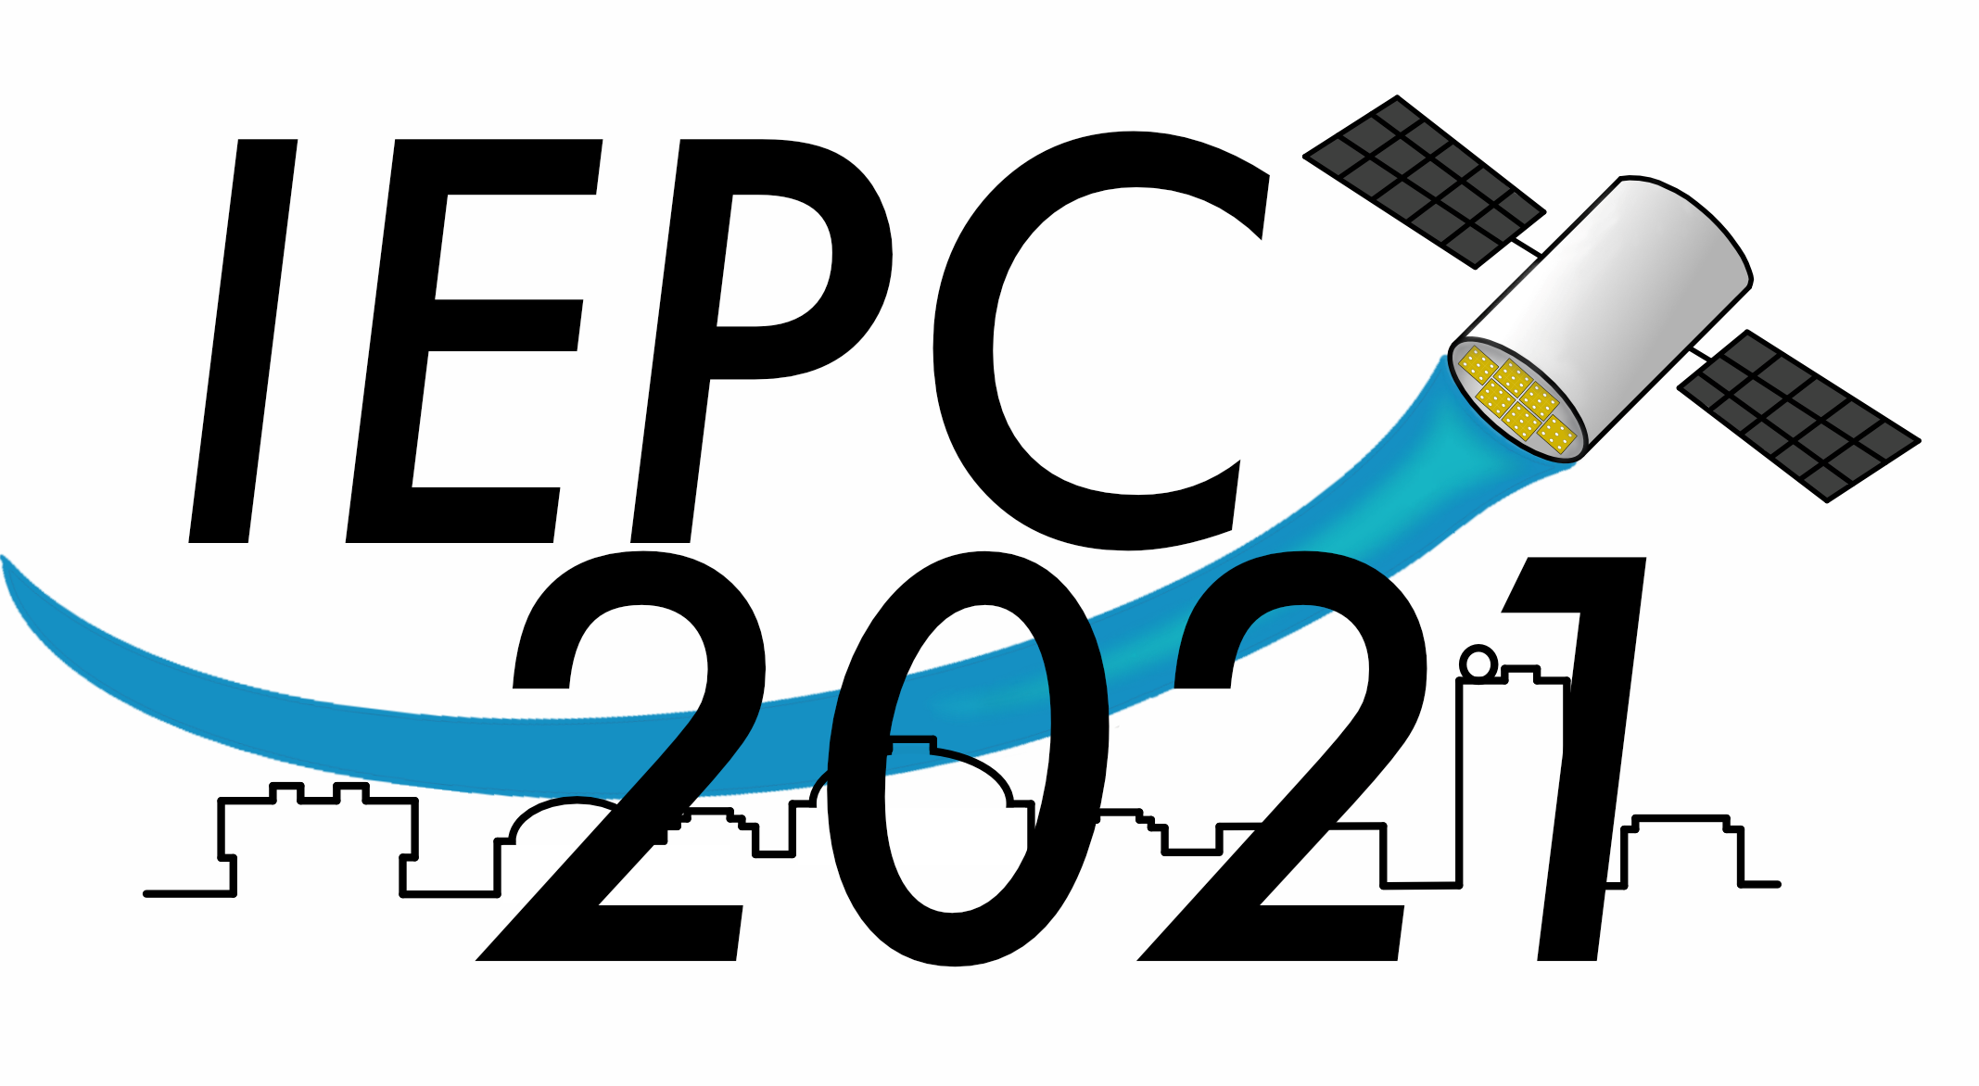
Fig. 1 You may decide to include a figure or two.

Conclusion
A conclusion section is not required, though it is preferred. For the purposes of abstract submission, you may elect instead to elaborate on the planned work and anticipated results.
Please visit iepcboston.org/abstract to submit and email iepc2021-tc@mit.edu with any questions.
∗Insert Job Title, Department Name, Address/Mail Stop, and AIAA Member Grade (if any) for first author.
†Insert Job Title, Department Name, Address/Mail Stop, and AIAA Member Grade (if any) for second author.
‡Insert Job Title, Department Name, Address/Mail Stop, and AIAA Member Grade (if any) for third author.

Table 1 You may also decide to include a table.

Key Dates

Abstract Submission Opens September 1st, 2020 IEPC2021 COVID Decision November 1st, 2020 Abstract Deadline November 15th, 2020 Notification of Acceptances Marchst, 2021 Deadline for Full Paper Submission June 1th, 2021 Tentative Conference Dates June 20-24, 2021

References
[1] Petro, E., Lemmer, K., and Lozano, P., “Abstract Template for the 37th IEPC Conference,” Technical Committee Notes, Vol. 1, No. 1, 2020, p. 42. https://doi.org/xx.yyyy/z.zzzzz.

